Weekly Lesson Plan-Project Work
Date: July 21, 2014 Classroom: Red Room Study Topic: Healthy Bodies Phase: 2/3 Teachers: Ms. Bobotek and Mrs. Wiest
Discussion/Activity for Meeting Time  What is a nutritionist? What questions do you have for a nutritionist?  How can we share with others the information we have learned about healthy bodies? Where can we find the answers to the rest of our questions?  Let’s go to an exercise class.  We will take a tour of the UMD Health Center, what will we see there?  What do you remember from our field trip to the Health Center? | Fieldwork/Investigation for Center Time  Expert: Colleen Davis the director of sports nutritionist at the UMD, will come in to answer our questions about nutrition.  Field Trip: We will walk to the UMD Health Center for a tour to see an x-ray room, meet a doctor and find out what is involved in patient assessment.  Investigation: Children will go to a Zumba/Yoga class and learn new fun ways to exercise their muscles. | Representation/Display  Culmination: Children will start to think of ways to culminate the Healthy Body study using technology.  Literacy: Children will continue reading informational texts including My Body by Pinnington and Inside the Body by Ganeri.  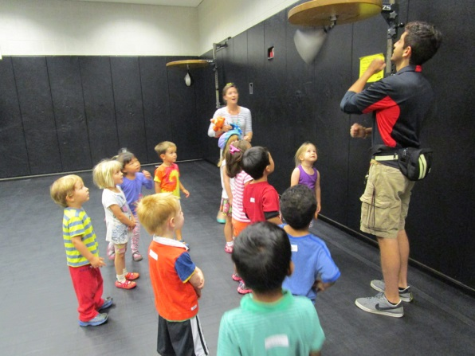
Literature /Art: We will read books by Gerald McDermett including Pig Boy, Arrow to the Sun, and Anansi the Spider. They will discuss his art work and describe how they might use some of his techniques in their own expressions of art.
Mathematical Thinking: We will use unifix cubes in a variety of ways to count, measure, and create number sentences.
Science- Children will explore a body model
Cooking: Everyone will have an opportunity to make hummus as a dip for vegetables and whole wheat pita.
Music: Children will move to some of our favorite CD’s during outside time .
Outside: T-ball, lacross and hockey equipment will be available to try out.
Reminders: Children need to wear closed toe athletic shoes and bring in $5 for our Zumba/Yoga class on Wednesday.

